Rodrigo Brasil 10/2023

### **Part 1: Topology 1/2**

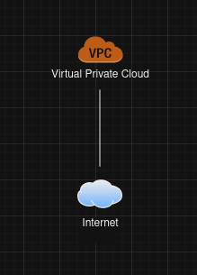

### **Part 2: Create a VPC**

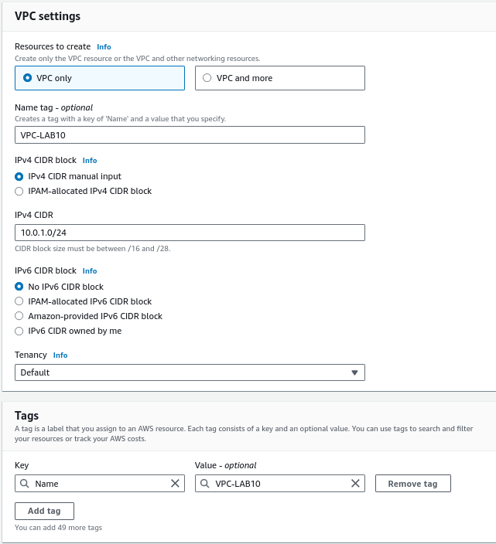

### **Part 3: Create VPC subnets**

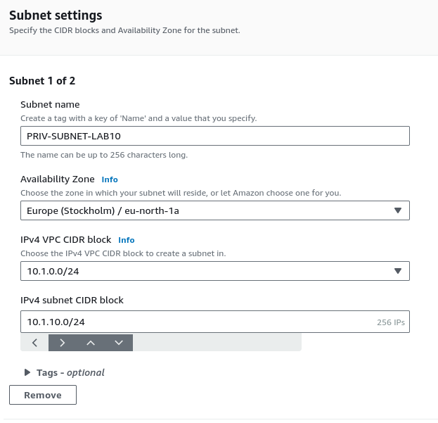

Private Subnet

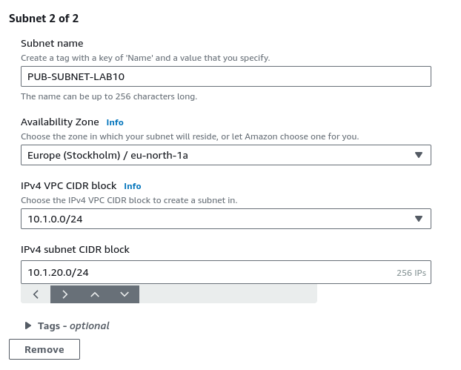

Public Subnet

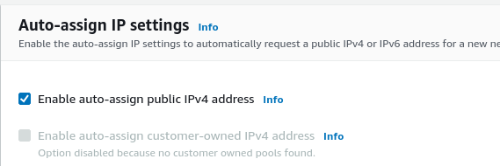

Auto-assign box checked

### **Part 4: Create an Internet gateway (IGW)**

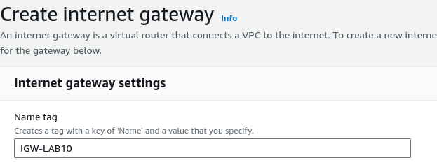

Internet gateway created

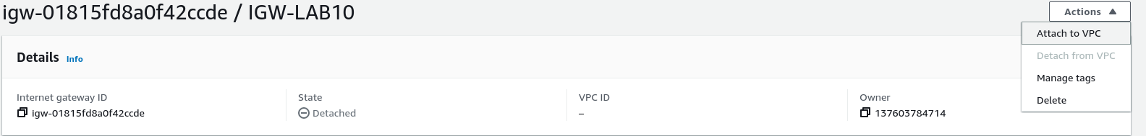

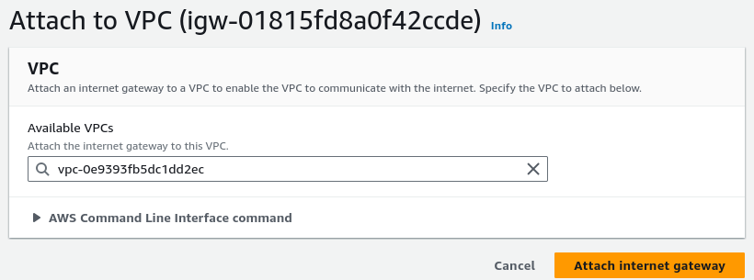



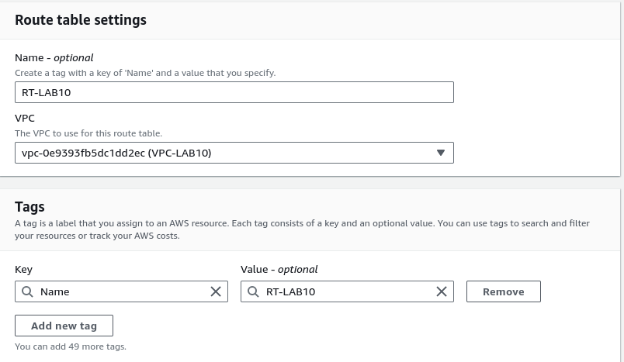

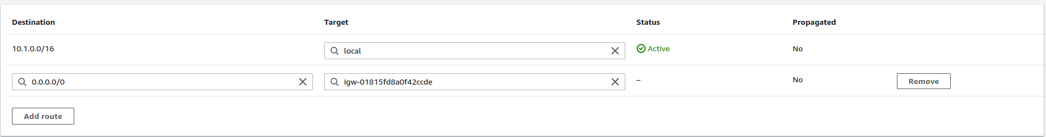

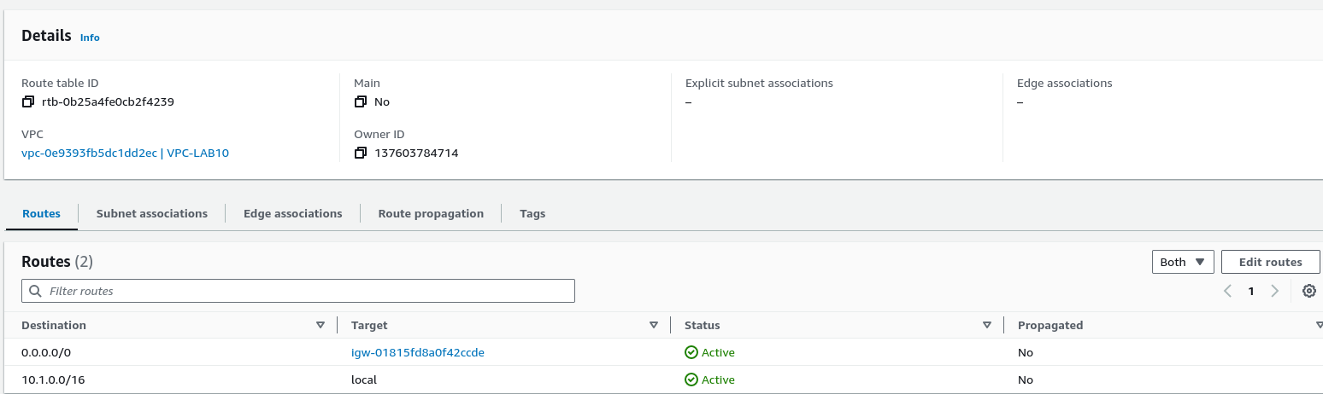

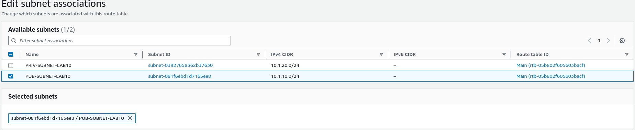

### **Part 5: Create Security Groups for subnets**

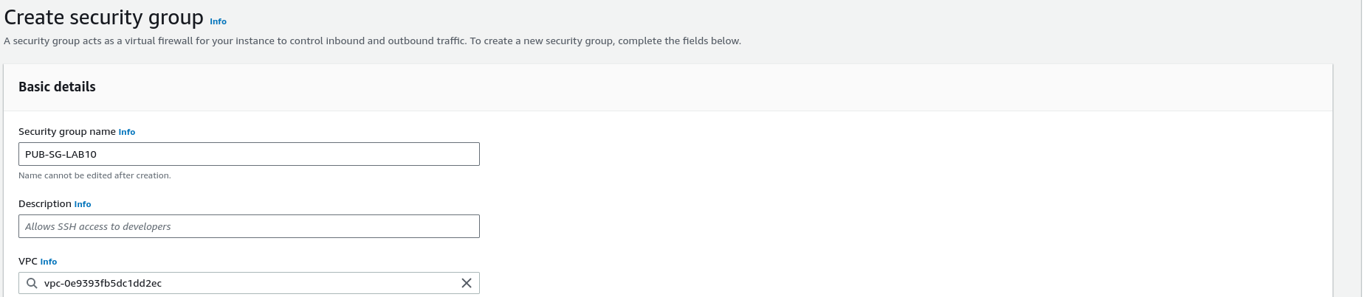

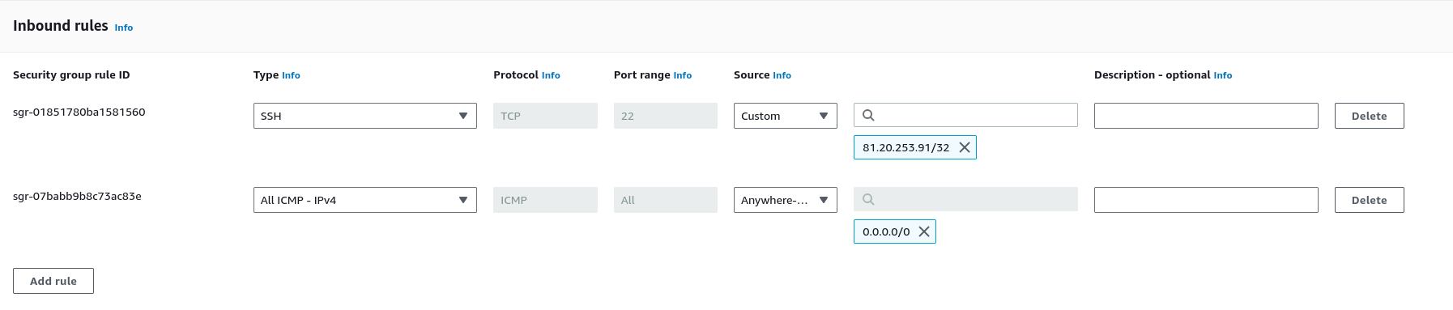

Public

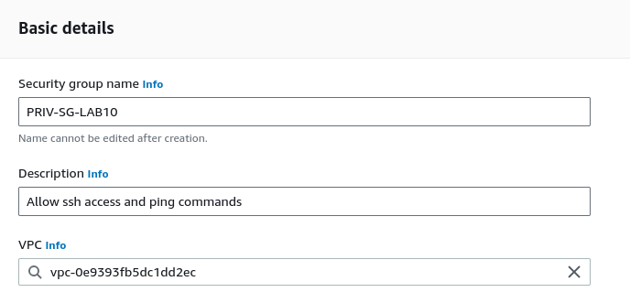

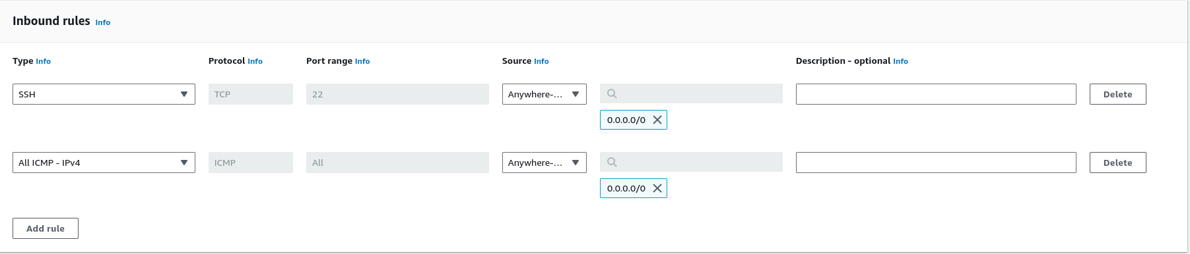

Private

### **Part 6: Create EC2 Instances**

Public E2C Instance

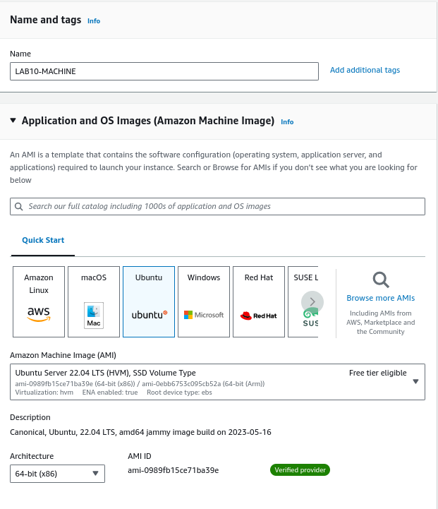

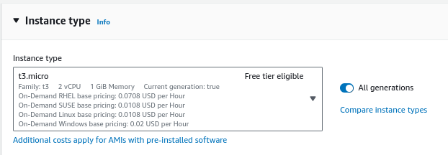

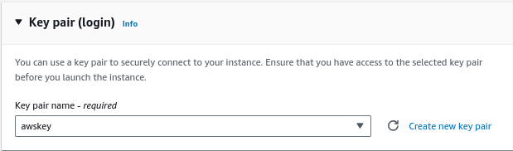

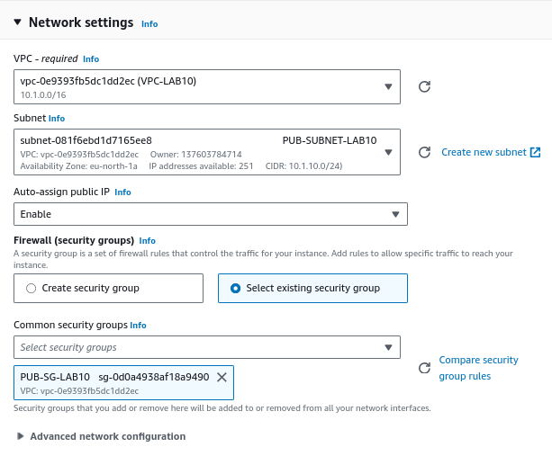

Private E2C Instance

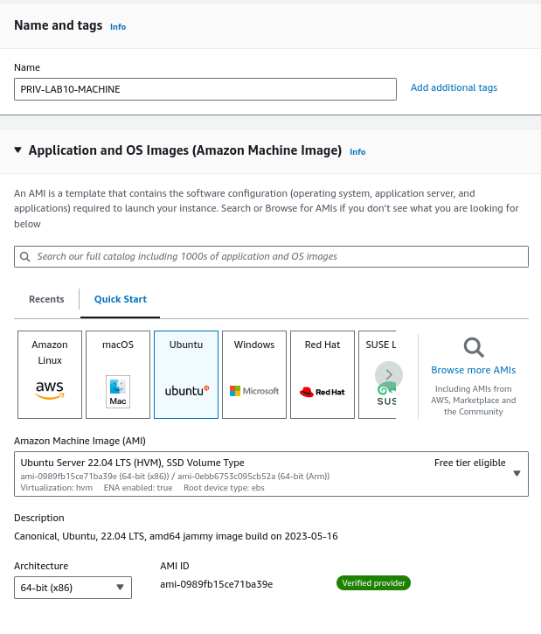

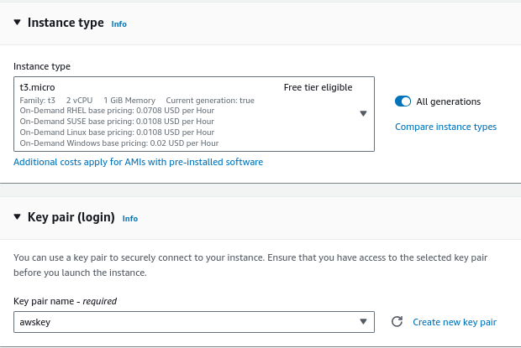

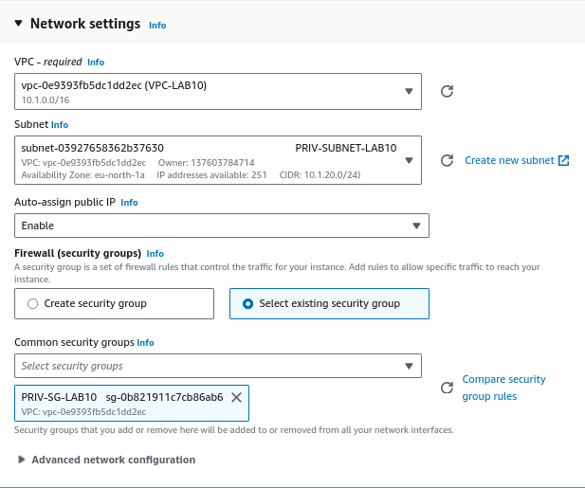

### **Part 7: Testing Connectivity**

Public E2C Instance ping connection

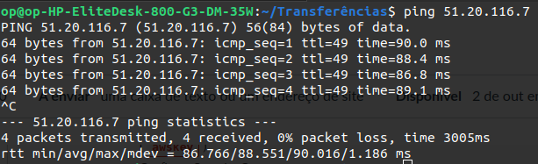

Public E2C Instance SSH connection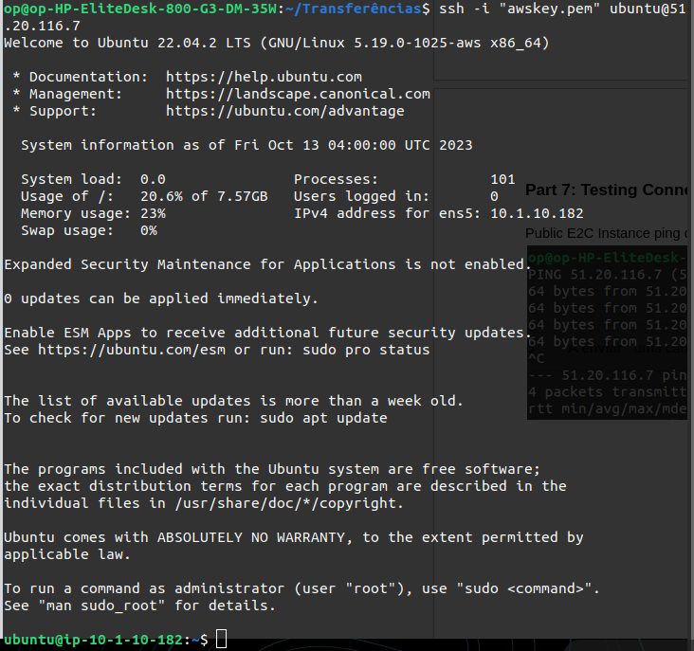

Both connections were successful

Private E2C Instance Ping connection

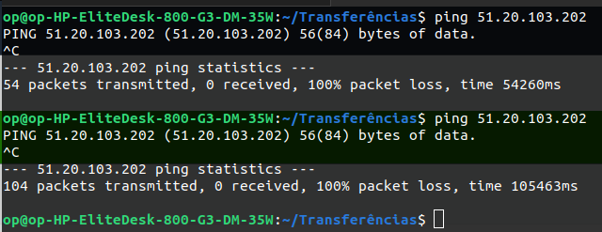

Private E2C Instance SSH connection

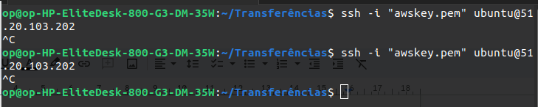

Both connections were not successful

### **Part 8: Topology 2/2**

